ROUND 1

Q1.1) In a given triangle ABC, using the usual notation, side a = 3 cm, side b = 4 cm and side c = 5 cm

Find the numerical value of Sin(A) + Sin(2B) + Sin(3C).

Answer in form , where a and b  N, in simplest form.

Q1.2) Find, in terms of n, the value of 

Answer in simplest form

ROUND 2

Q2.1) Four integers are added to the set {3, 4, 5, 5, 8} increasing the mean, median and mode each by 1.

Write down the elements of the new set **in ascending order.**

Q2.2) What is the value of the base **b**, in surd form, when



ROUND 3

Q3.1) Find the value of the integral 

Q3.2) Find the 5th term of the expansion  .

Answer in simplest form , where a, p, q  N.

ROUND 4

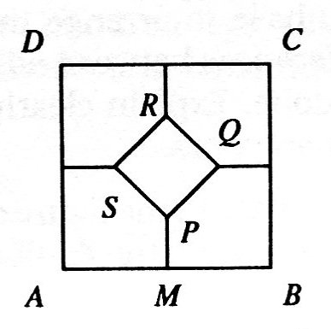Q4.1) ABCD and PQRS are concentric squares.

The diagonals of PQRS are parallel to the sides of ABCD.

If |AB| is 1 cm and |PQ| = cm, calculate the length of [PM]



where M is the midpoint of the line segment [AB].

Answer in form , where a , b and c N, in simplest form.



Q4.2) Find all the cube roots of .

Answers in the form r(Cos(A) + iSin (A)), where A is in degrees.

ROUND 5

Q5.1) Given that a and b  R, o < a < b and find the numerical value of .

Answer in simplest surd form.

Q5.2) Solve for x and y

x(x + y) = 108

y(x + y) =



Answers in the form (x, y) where x and y Q



ROUND 6

Q6.1) A jar has 499 fair coins and one similar coin with heads on both sides.

A coin is chosen from the jar at random and flipped 9 times.

Given that it comes up heads every time, what is the probability that the coin is the two headed coin?

Answer in form , where a and b  N.

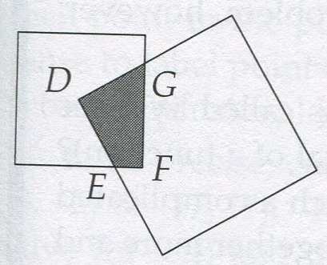Q6.2) A square of side 3 m and a square of side 4 m overlap as shown in the diagram. D is the centre of the 3 m square.

Find the area of the shaded region DGFE.

Answer in the simplest form  , where a and b  N.

ROUND 7

Q7.1) Solve for x : , where x  R.

Answer in for a  x  b in simplest surd form.

Q7.2) If is written as an integer how many times does 5 appear in the answer?



Q7.3) Two vertices of an equilateral triangle lie on the line y = 2x – 2, and the third vertex lies on the line y = 2x + 2.

Find the area of the triangle.

Answer in form , where a, b and cN.

Q7.4) Three fair 6-sided dice are thrown.

What is the probability that the three numbers rolled are three consecutive numbers, in some order?

Answer in the simplest form , where a and b  N.

ROUND 8

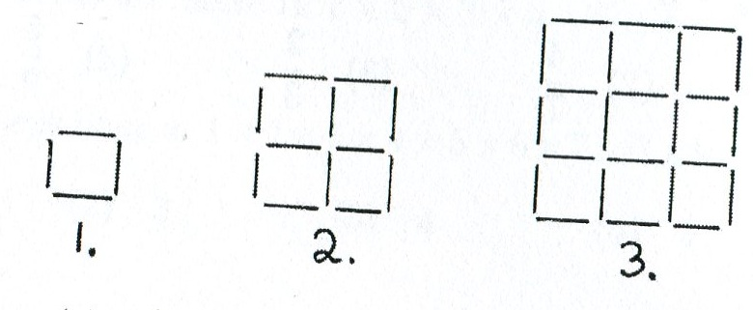

Q8.1) Square grid patterns of matches are shown, namely a 1-square, a 2-square and a 3-square.

How many matches must be added to a 500-square to make a 501-square?

Q8.2) Find all the complex numbers such that |z – 1| = |z + 3| = |z – i |, where z = x +iy.

Answers in the form a + ib where a and b  R.

Q8.3) Find the values of x and y for which .

Answers in the form (x , y), where x and y  Z.

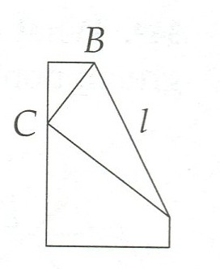

Q8.4) A corner of a rectangular piece of paper of width 8 cm is folded over so that it coincides with the point C on the opposite side.

Given that |BC| = 5 cm, calculate, in cms, the length of the fold *l.*

Answer in form , where a and b  N.