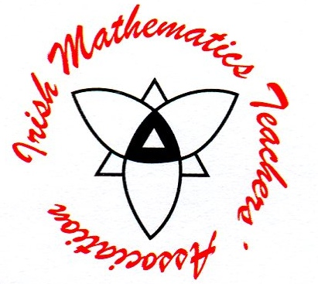

Babhta 1 Round 1

Q1.1 Find the equation of the line passing through ( - 3, 2 ) which is perpendicular to the line 5x – 2y + 7 = 0.

Answer in the form ax + by + c = 0, where a , b and c  Z.

Q1.2 How many triangles can be formed using the vertices of a regular dodecagon (12 sided polygon).

Answer in simplest form.



Babhta 2 Round 2

Q2.1 Given that find, in degrees, the values of A

for which Tan(A) = 2Sin(A).

Q2.2 Given z = x + iy find all the solutions for which 

Answers in form a + ib, a, b R in non decimal form, where appropriate where i = .



Babhta 3 Round 3

Q3.1 Find the numerical value of the integral 

Answer in form  where a and b  N.

Q3.2 Given  =  **a** write  in terms of **a.**



Babhta 4 Round 4

Q4.1 Find the points of intersection of the circle 

and the line x + y -7 = 0

Answers in form (x,y) , where x and y  Z.

Q4.2 What is the probability that the ace of hearts and the ace of spades in a standard pack of 52 cards will occur next to one another in a thoroughly shuffled standard deck of 52 cards?

Answer in simplest form , where a and b  N



Babhta 5 Round 5

Q5.1 Solve for real x : .

Q5.2 Divide  by .



Babhta 6 Round 6

Q6.1 15 balls are arranged in a straight line at intervals of 2 metres and a bucket is placed in the same straight line, 5 metres from the first ball to the left of the leftmost ball. The competitor has to start from the bucket, bring the balls one at a time and place them in the bucket.

What is the total distance he has to travel?

Q6.2 Two congruent triangles are placed so that their hypotenuses coincide.

If the hypotenuse of each triangle is 12 cm, calculate the area common to both triangles.

Answer in simplest form , where a and b  N.



Babhta 7 Round 7

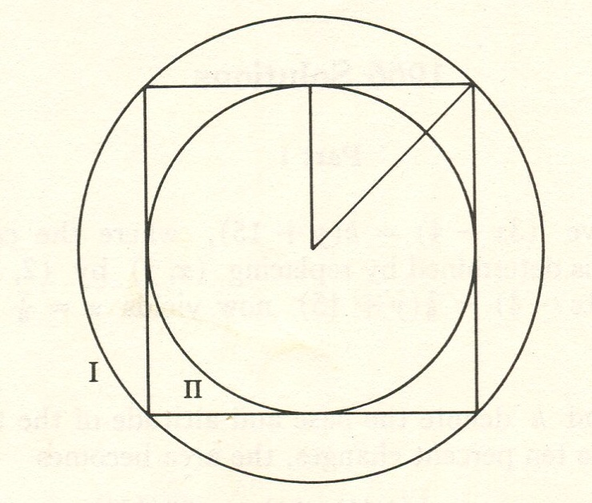

Q7.1 Circle I is circumscribed about a given square and circle II is inscribed in the same given square.

Find the ratio of the area of circle I to circle II.

Answer in simplest form a : b, where a and b  N.

Q7.2 Find the values of x for which  = 82.

Q7.3 Given that  , find the numerical value of .

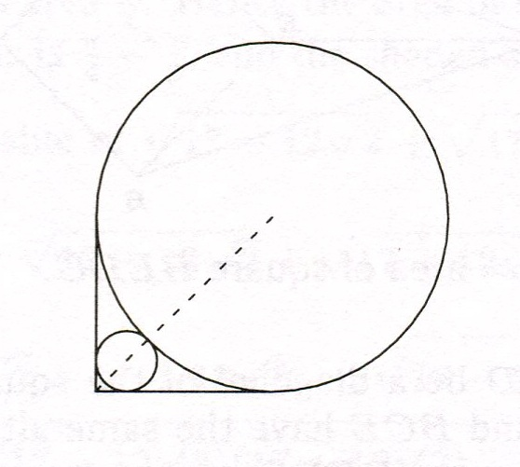

Q7.4 Two line segments are perpendicular and are tangents to the large circle.

It is required to place a small circle in the space left by the large circle as shown.

Given that the radius of the large circle is  **r** and the radius of the small circle is **s** find the ratio **r : s.**

Answer in form a + : 1 , where a, b and c  N.



Babhta 8 Round 8

Q8.1 Given that a, b and c are real numbers such that



Find the numerical value of .

Q8.2 The equation , where p and q are different numbers, has solutions x = p and x = q where p and q 0

Determine all such ordered pairs (p , q), p and q  Z.

Answer in simplest form.

Q8.3 Find the possible values of p  R so that the two lines

x – y = 2 and px + y = 3 intersect strictly in the first quadrant.

Q8.4 At the beginning of each of 20 consecutive years €250 is invested at 4% APR.

Find the total amount at the end of the 20 years.

Answer to nearest euro.